# Alloy 8 Demo Site

*Updated to latest 8x versions available as of June 09, 2015*

## Disclaimer

* Completely unsupported. ☺ However, a great starting point. If anything is unclear Google is your best friend.

## Add-ons

* Google Analytics
* SiteAttention SEO
* Social Reach
* PowerSlice
* Projects
* Content Collaboration
* Languages
* Find
* MenuPin
* Carousel
* RSS Reader
* Blog
* Tree Icons
* Live Monitor
* Styles Properties
* Silverpop
  + Limited but great for talking about the tie in to MA related personalization, DXH, and contact data collection via forms
* **NEW – SocialFeedBlock to show Twitter, LinkedIn, Facebook feeds**
* More!?

## Configs

* Personalized Dashboards and workspace in the editorial interface for all users
* Various visitor groups
  + Both “Interested in Alloy Track” and “Interested in Newsletter” have personalized content on home page and are category based so viewing the right content 1-2 times will show personalization in effect with ease.
  + Others as well
* Limited pages available below “News Page” type
  + Try creating a page under “Press releases”
* Several additional languages and fallbacks for each non-English
* SITE TEMPLATES area with second skeleton site and various configs to make your life better
  + Great for personalized customer demos
* Workflows
  + Setting a page as “Ready to Publish” under Press Releases will kick off a workflow for approval by Administrators or ContentEditors (e.g. epiadmin)
  + Additional workflow configs also enabled for pages under Products
  + Note, may not work for Azure Websites
* Content collaboration conversations between epiadmin and nancy if you select About Us~News and Events~Press Releases
* Simple Alloy Track Mobile Campaign in Projects
* Additional forms
* Additional categories that are applied to various pages
* Office Locations page with fake Google Map (99.9999% of people will never ask)
  + Note, there are blocks available if you want the real item
* Many other general content changes and improvements
* **NEW – Referral from Twitter Visitor Group**
* **NEW – Twitter feed block shown on home page for visitors referred from Twitter**
* **NEW – PowerSlice moved to left hand side of page for all users**
* Many more!

## Basic Setup

* Set up all System Requirements
  + <http://world.episerver.com/documentation/Items/System-Requirements/System-Requirements---EPiServer/>
* Unzip the package in Dropbox to a location of your choosing
* If you want to IIS for the web server follow the steps below. Otherwise if using VS skip ahead to the next major bullet
  + Change the root folder access security settings to allow IUSR and IIS_IUSRS access
  + Create a new site in IIS and point it at the root folder location
    - Set up a site binding and related URL
      * Ensure you have a site binding entry that catches all other incoming to that domain

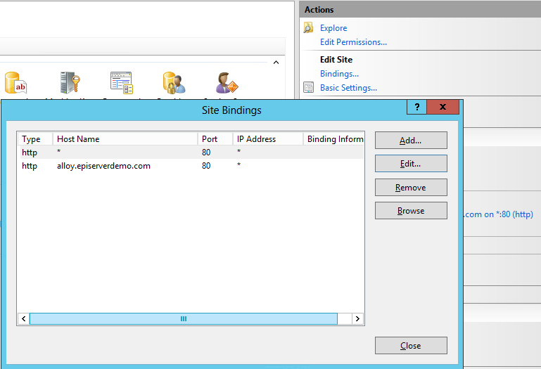

* + - Add a similar entry to your hosts file if you want to fake the DNS
      * <http://www.howtogeek.com/howto/27350/beginner-geek-how-to-edit-your-hosts-file/>
  + Update setting in the administration interface under Config~Manage Websites. Update both sites!
    - For example,
      * alloy.com
      * microsite.alloy.com

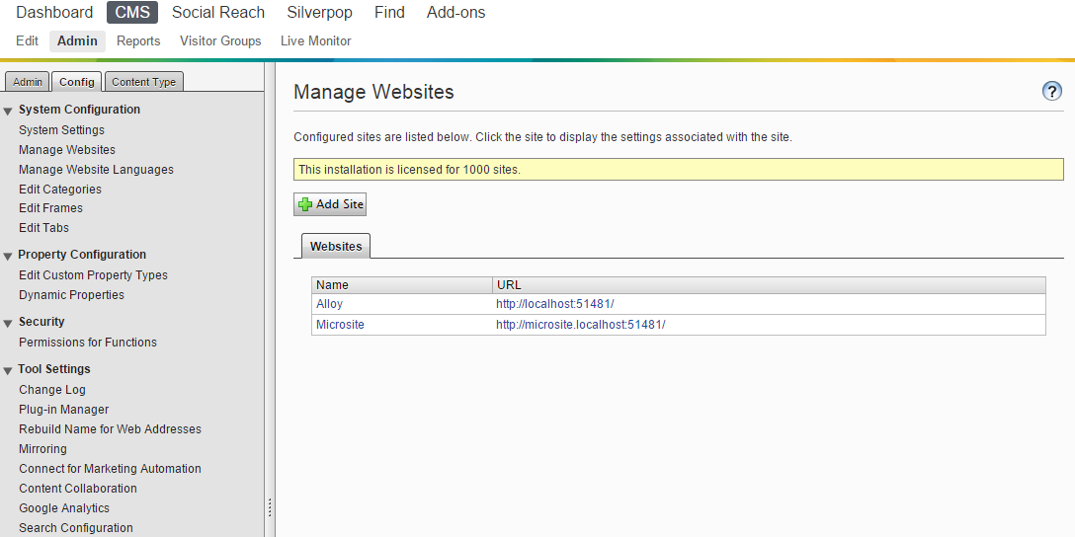

* + Navigate to the Application Pools in IIS, select the app pool you just created, and change “Load User Profile” to true

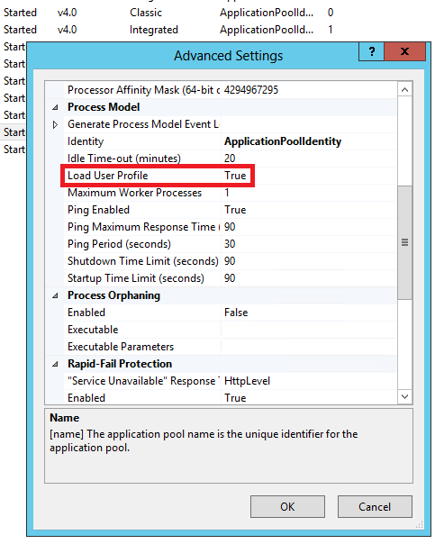

* + Additional info and options for why/how:
    - <http://blogs.msdn.com/b/sqlexpress/archive/2011/12/09/using-localdb-with-full-iis-part-1-user-profile.aspx>
* Set up your own Find index and update web.config accordingly
  + <http://find.episerver.com/>
* Obtain and add a new license to the root directory
  + <http://license.episerver.com>
* Configure Google Analytics account
* Configure Social Reach account(s)
* Optionally…
  + If you want the LanguageManager to work you need to set up your own related Bing or Google developer account and update the config at:
    - \modules\_protected\EPiServer.Labs.LanguageManager\ EPiServer.LanguageManager.config
    - Additional info: <http://world.episerver.com/add-ons/episerver-languages/configuring-auto-translation/>
  + If you want the Silverpop Connector to work you need to configure as appropriate including the “Refresh token” and tracking code in the administration interface. The settings included in this package are not functional.
    - <http://world.episerver.com/add-ons/connect-for-marketing-automation/configuring-silverpop/>

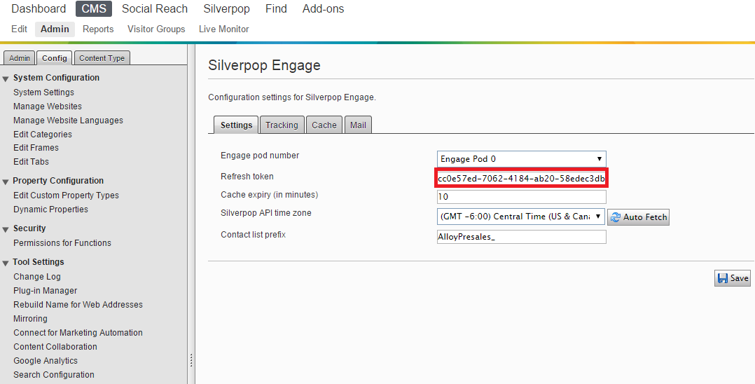

## Logins

* Admin user
  + U: epiadmin
  + P: ep!pass
* News editor
  + U: nancy
  + P: ep!pass
  + Notes: Limited access to News and Events area of site and Blocks/Media area, various top navigation menus removed, no ability to publish.
* Product editor
  + U: peter
  + P: ep!pass
  + Notes: Limited access to Product areas of site and Blocks/Media area, various top navigation menus removed, no ability to publish.

## Updates

* If you apply EPiServer updates at any time and need to perform a database upgrade via the Visual Studio Package Console using the “update-epidatabase” database command you need to update the connectionStrings. Currently these are using LocalDB settings and will not work as expected in this scenario. Change the settings for AttachDbFilename to the local path, run the upgade, and then reset it back to what it was previously.
  + AttachDbFilename=c:\path\to\your\<database>.mdf
* Additional info:
* <https://github.com/OXXAS/CommerceStarterKit/>

**Enjoy!!!**